PLEASE NOTE: THIS IS ONLY A TEMPLATE TO ASSIST YOU IN COMPLETING THE ONLINE APPLICATION. APPLICATIONS MUST BE SUBMITTED ONLINE. THIS WORD DOCUMENT WILL NOT BE ACCEPTED.

Information in red italics are additional instructions for your convenience.

Information in Black is required for your application.

SECTION 1: CONTACT INFORMATION

FOR THE DISTRICT*
Name of the School District: _________________________________________________
DUNS #: _________________________________________________

Is the district’s insurance provided through a risk pool?
( ) Yes
( ) No
Mailing Address: Street Address or PO Box: _______________________
City: ______________
Zip Code: ____________

The contacts below can be the same person. The Primary Contact should be our first point of contact for this application. The Contract Signer (often the superintendent) should be the person authorized to sign the contract on behalf of the district. The Financial Contact will be asked through a secure portal to provide the district’s banking information for electronic payments.

Primary Contact*
Name: _________________________________________________
Title: _________________________________________________
Email Address: _________________________________________________
Phone Number (XXX) XXX-XXXX: _________________________________________________

Contract Signer*
Name: _________________________________________________
Title: _________________________________________________
Email Address: _________________________________________________

Financial Contact*
Name: _________________________________________________
Title: _________________________________________________
Email Address: _________________________________________________

How many community-based organizations (CBO's) would be partnering on this grant? *
Note: If applicable, the next page will collect contact information for each of these organizations.
( ) 0
( ) 1
( ) 2
( ) 3

SECTION 1: CONTACT INFO FOR THE CBOS
Please be sure to include accurate information for each CBO and whenever possible, direct phone numbers for contacts instead of the general phone number for the organization.
This section will self-populate in the online application based upon the number of CBOs you selected.

Community-Based Organization 1*
Organization Name: _________________________________________________
Contact Person: _________________________________________________
Title: _________________________________________________
Phone Number of Contact Person (XXX) XXX-XXXX: _________________________________________________
Email of Contact Person: _________________________________________________

Community-Based Organization 2*
Organization Name: _________________________________________________
Contact Person: _________________________________________________
Title: _________________________________________________
Phone Number of Contact Person (XXX) XXX-XXXX: _________________________________________________
Email of Contact Person: _________________________________________________

Community-Based Organization 3*
Organization Name: _________________________________________________
Contact Person: _________________________________________________
Title: _________________________________________________
Phone Number of Contact Person (XXX) XXX-XXXX: _________________________________________________
Email of Contact Person: _________________________________________________

SECTION 2: STUDENT ACTIVITY DESCRIPTION
Please make your best estimate of numbers and countries of origin for students.

1. Total Number of Students to be served in 2026-2027
_________________________________________________

2. Provide estimated percentages for countries of origin for students to be served
Note: Estimated percentages must equal 100%
________Percentage of Ukrainian Students to be served in 2026-2027
________Percentage of Afghan Students to be served in 2026-2027
________Percentage of Students from other countries (other than Ukraine and Afghanistan). Please describe below if applicable.

Projected other countries of origin.
____________________________________________
____________________________________________

How many student activities will you be entering?*
You can select up to 12 activities, but you do not need to submit that many.
( ) 0
( ) 1
( ) 2
( ) 3
( ) 4
( ) 5
( ) 6
( ) 7
( ) 8
( ) 9
( ) 10
( ) 11
( ) 12

For the questions below, please be specific and separate each activity based upon the content.
You need to fill out the fields below for every activity.

Activity 1*
a) Lead Agency: _________________________________________________
b) Name of Activity: _________________________________________________

c) Activity Description
____________________________________________
____________________________________________

d) Type of Activity
Please note:
- Core activity types include: (1) Literacy and STEM; (2) School Navigation/Integration; (3) Graduation and Beyond; (4) Mentoring; and (5) Behavioral Health/Mental Health Supports.
- Select the activity type that is most applicable.
- Stand-alone field trips and recreational activities are NOT allowable. You can use grant funds for field trips/recreational activities in conjunction with a core activity.
- Orientation has been removed from our type descriptors because we have fewer new arrivals, but you can provide this service under School Navigation/Integration.
- We added Behavioral Health/Mental Health Supports, which includes counseling, group therapy, support groups, specialized programming to address trauma, to improve well-being and to build resiliency, etc.

Select only one activity type.
( ) Literacy and STEM
( ) School Navigation/Integration
( ) Graduation and Beyond
( ) Mentoring
( ) Behavioral Health/Mental Health Supports

e) Target Audience
Check all that apply
[ ] Elementary School Students
[ ] Middle School Students
[ ] High School Students

f) Location of Activity
Check all that apply
[ ] Virtual
[ ] School Building
[ ] CBO Building
[ ] Student’s Home
[ ] Offsite

g) Time of Day/Year
Check all that apply
( ) School Day
( ) After School
( ) Weekends
( ) Evenings & Weekends
( ) Summer
( ) Other School Breaks

h) Program days
( ) One Time
( ) Monthly
( ) Quarterly
( ) 1 day per week
( ) 2 days per week
( ) 3 days per week
( ) 4 days per week
( ) 5 days per week
( ) Other (please specify in narrative section)

i) Program hours
( ) 1-2 hours per program day
( ) 3-4 hours per program day
( ) 5-6 hours per program day
( ) 7-8 hours per program day

j) Please provide an estimated number of students to be served through this activity:________________________________________________
COPY & PASTE a-j ABOVE AS NEEDED FOR EACH ACTIVITY (MAX 12). This section will self-populate in the online application based upon the number of activities you selected.
THESE ARE JUST STUDENT ACTIVITIES (parent & staff are in the next question).

SECTION 2: PARENT ACTIVITY DESCRIPTION
NOTE: Parent and Staff activities are optional.

1. Total Number of Parents to be Served: ___________________________________________

2. Total Number of School Staff to be Served: ________________________________________

Parent & Staff Activities

Activity 1
a) Lead Agency: _________________________________________________

b) Name of Activity: ______________________________________________
c) Type of Activity (Select only one.)
( ) Parent Orientation to Schools
( ) Parent Workshops
( ) Parent School Navigation
( ) Staff Professional Development

d) Frequency (Select only one.)
( ) Weekly
( ) Monthly
( ) Quarterly
( ) Annually

COPY & PASTE a-d ABOVE AS NEEDED FOR EACH PARENT OR STAFF ACTIVITY. This section will be presented as a table in the online application and allows for up to 5 activities max.

SECTION 3: NARRATIVE
Section 3 is the place to share more detailed descriptions and explanations. Please read all of the bulleted narrative prompts and respond appropriately to all prompts.

1A. STUDENT NEEDS (If proposing student activities)
- Describe any changes to your refugee population in the last year.
- Describe the refugee student population to be served.
- How did you determine the number of refugee students to be served?
- What are the specific academic and social adjustment needs that you plan to address?
- What other refugee student needs will your project address?
____________________________________________
____________________________________________

1B. PARENT/STAFF NEEDS (Only if proposing parent and/or staff activities)
- What are the specific needs that you plan to address?
____________________________________________
____________________________________________

2A. PROJECT DESCRIPTION*
- Describe your full project.
____________________________________________
____________________________________________

2B. PROJECT RATIONALE*
- What is your rationale for proposing this project?
- How will your proposed project address the needs identified above?
____________________________________________
____________________________________________

3A. PARTNERSHIP: PROGRAMMING*
If you have multiple CBOs, please specify the role of each partner.
- How are these CBO partners uniquely qualified to support services for refugees in your district?
- What are the roles and responsibilities of the district and partners (CBOs)?
____________________________________________
____________________________________________

3B. PARTNERSHIP: OUTREACH (If proposing student and/or parent activities)
- Who will identify and conduct outreach to eligible participants?
- How will that be done?
____________________________________________
____________________________________________

3C. PARTNERSHIP: DOCUMENTATION
- If proposing student activities:
  - For the various student activities proposed (in-person, virtual, hybrid), who will collect immigration documentation?
  - How will that be done?
- If proposing parent activities:
  - ​​​​​​​Describe who will collect immigration documents and how that will be done
____________________________________________
____________________________________________

4. REFLECTION. (Previously funded Districts ONLY)
- If you were funded in 2025-2026, what were your successes?
- What were your challenges?
- How do you plan to mitigate these challenges in the upcoming school year?
____________________________________________
____________________________________________
5. EXPERIENCE (NEW DISTRICTS ONLY)
- Describe your district's experience in serving refugees and/or providing additional supports for refugees.
- Describe your district's experience in partnering with community-based organizations to serve refugees.
- Describe your district’s prior accomplishments and challenges related to supports for refugees.
____________________________________________
____________________________________________

SECTION 4: BUDGET
Please work with your CBOs to provide detailed budgets.

1. BUDGET FOR DISTRICT*
Can be 0
________Certificated Salaries, Benefits, Payroll Taxes
________Classified Salaries, Benefits, Payroll Taxes
________Purchased Services
________Supplies
________Travel
________Administrative/Indirect Costs (limited to 15% or your district's federally approved indirect rate)
________Total Allocation for District
What is the indirect rate that is being applied by the district? ___________
Is this your district’s federally approved indirect rate?
( ) Yes
( ) No (Explain below)
Why are you using an indirect rate other than your federally approved indirect rate?
____________________________________________
____________________________________________

2A. BUDGET CBO 1
________Salary, Wages & Benefits
________Rent
________Utilities
________Equipment
________Printing
________Supplies
________Food
________Travel
________Insurance
________Phone/Fax
________Professional & Contractor Fees
________Information Technology & Website Fees
________Professional Development & Training
________Other (Specify in question 4C below)
________Administrative/Indirect Costs (limited to 15% or your organization's federally approved indirect rate)

What is the indirect rate being applied by [this CBO]? ___________
Does [the CBO] have a federally approved indirect rate?
( ) Yes, and that rate is being applied to this grant.
( ) Yes, but that rate is NOT being applied to this grant. (Explain below)
( ) No, this organization does not have a federally approved indirect rate.
Why are you using an indirect rate other than this organization’s federally approved indirect rate?
____________________________________________
____________________________________________

COPY & PASTE ABOVE BUDGET AS NEEDED FOR EACH CBO. This section will self-populate in the online application based upon the number of CBOs you entered. Be sure to match the budget to the correct CBO.

4A. BUDGET JUSTIFICATION*
- Please justify your budget by explaining the relationship between the budget line items and the proposed activities.
- Discuss the necessity and reasonableness of the proposed costs.
____________________________________________
____________________________________________

4B. BUDGET JUSTIFICATION: STAFFING*
- Please list all positions to be funded through this grant. This includes both district positions as well as community partner positions. For both the district and the community-based organizations, please list the name of person, the entity they work for, their title, the FTE allocated to these funds, and describe their role/key responsibilities. For example: “Jane Smith, Refugee Community Nonprofit, Refugee Youth Afterschool Program Coordinator, 0.5 FTE, Responsibilities: Plan afterschool activities, Facilitate programming for youth, Manage daily operations, Supervise Volunteers, Collect immigration documents from families, Communicate with Families.”
____________________________________________
____________________________________________

4C. BUDGET JUSTIFICATION: OTHER
- If you are requesting funds for Purchased Services or Other, please explain in detail here.
____________________________________________
____________________________________________

Once you reach this point in the online application you will be ready for review and attestation.
THE DETAILED INSTRUCTIONS IN THE SCREEN SHOT BELOW WILL COME AFTER THE LAST QUESTION. MAKE SURE THAT YOU CLICK ON “SAVE AND RETURN LATER.” PLEASE READ CAREFULLY!
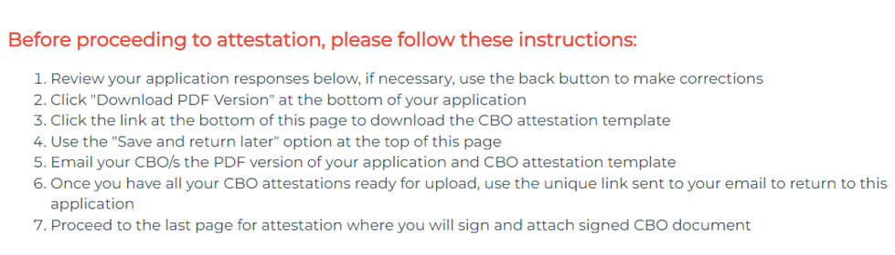
NOTE: You will need to “Save and return later” as CBOs must review the application.
Once you have reviewed your application and received attestation documents from your CBOs, proceed to the last step. The attestation in the online application should be completed by the district and looks like the screen shot below.
SECTION 5: ATTESTATION
I attest that I have reviewed this entire grant proposal and that all of the information provided in this proposal is true and accurate to the best of my knowledge.
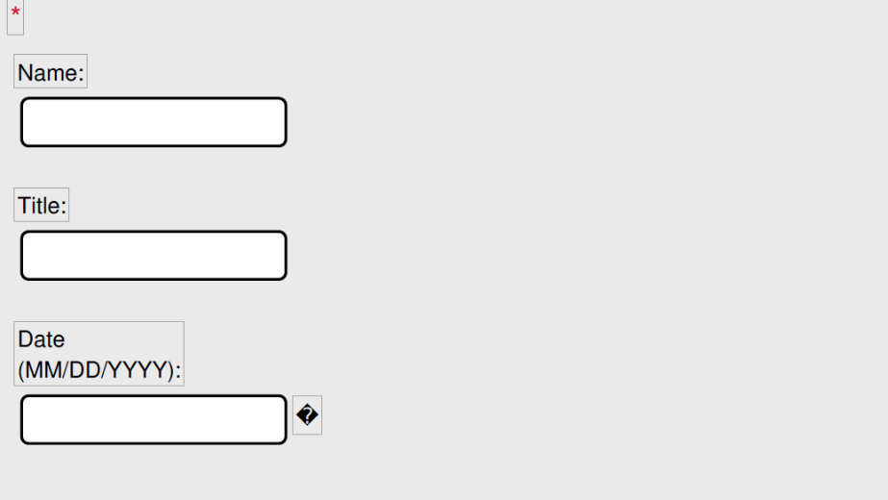

Upload a CBO Attestation for EACH Partner. This section is self-populating based upon the CBOs you entered in the contact section. PDF DOCUMENTS ARE PREFERRED.

CLICK SUBMIT!
You will receive a confirmation email with a PDF version of your application and attestation.

Thank You!

