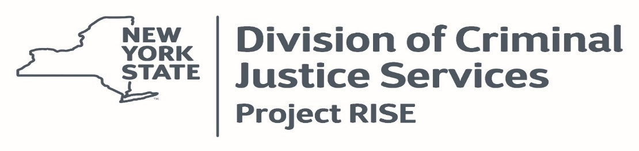

Workplan Template
Please complete for each lead agency and grassroots organization (pass-through) receiving funding through this grant. Depending on the program, there may be additional goals added. The template below can be used an example and include multiple goals.
NOTE: the following is provided as an example of what a completed goal section of the work plan should look like. Each Goal must be broken out into its own section and include the following information for each goal. Organizations MUST change this to reflect their proposed work.
Goal #1 (What do you want to achieve?): Reduce the number of youth of color placed in detention.
How does this align to the priority areas identified for Project RISE? Project RISE has identified addressing the underlying factors contributing to violence in the community. 2015 data show that youth of color represent 25% of total referrals to intake but 60% of youth detained at that point.
Objectives (How will you achieve the goal?): Implement an objective detention risk assessment instrument (RAI).
Desired Outcomes (What results do we expect?) Reduced overrepresentation of youth of color in detention admissions.
Action Steps
Task | Responsible Party | Target Date | Notes
- Complete a draft RAI for committee’s review | RAI Subcommittee (John Smith as lead) | 2/1/2016 | Circulate draft instrument one week before committee’s meeting on 2/7/16.

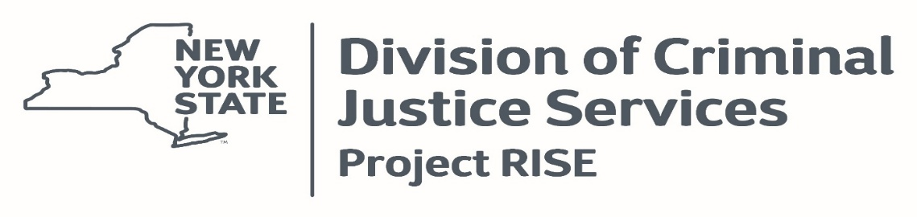
Workplan Template – Insert Organization Name
Please complete for each lead agency and grassroots organization (pass-through) receiving funding through this grant. Please add additional goals as necessary, via the same format as below. Your target date can be reflected as Month & Year (i.e. 10/2026) or a TBD if you are unsure.

Goal #1 (What do you want to achieve?):
How does this align to the priority areas identified for Project RISE in your jurisdiction?
Objectives (How will you achieve the goal?):
Desired Outcomes (What results do we expect?)
Action Steps
Task | Responsible Party | Target Date | Notes

