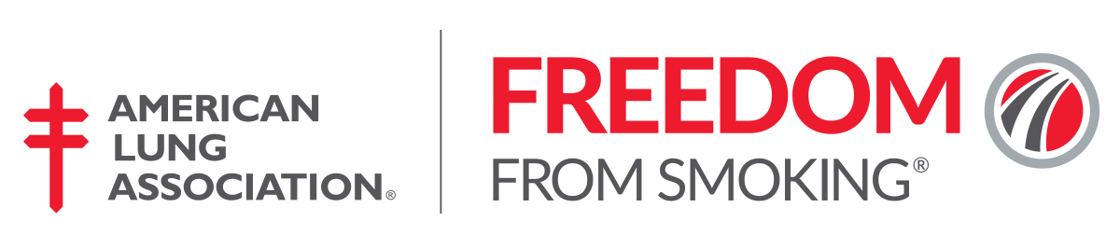

Quick Reference Guide to Ordering Materials for your FFS Clinic

All participants enrolled in a Freedom From Smoking® in-person group cessation clinic must receive a
Freedom From Smoking Kit Deluxe Package. This includes a participant workbook with activities, exercises and homework assignments to support all 8-sessions of the clinic and assist an individual in tailoring their own personalized quit plan. It also includes your choice of a relaxation exercise MP3 download access card or CD to assist participants with overcoming the psychological and behavioral challenges associated with quitting.

Item # | Title | Description | Cost
3304 | FFS Kit w/ MP3 Download- English | English in-person class participant workbook  and relaxation MP3 download access card (download exercises to up to 6 electronic devices) | $25 ea
3305 | FFS Kit w/ MP3 Download- Spanish | Spanish in-person class participant workbook  and relaxation MP3 download access card (download exercises to up to 6 electronic devices) | $25 ea
2915 | FFS Kit w/ CD- English | English in-person class participant workbook  and relaxation compact disc (CD). | $25 ea
2916 | FFS Kit w/ CD- Spanish | Spanish in-person class participant workbook  and relaxation compact disc (CD). | $25 ea

*Please note, the FFS Self-Help Kit is not a reasonable alternative for those enrolled in the in-person classes. This item is solely for those individuals preferring a self-guided method to cessation.

