Due no later than June 20, 2021.
Screening Form B is provided as an Excel® spreadsheet. If Excel is unfamiliar to you, or you do not use Microsoft Office products, there should be someone at your LEA who can help. If your computer asks you to “enable macros” or “disable macros” when you open the form, please click “disable macros.”
This report is expected from all public-school districts (LEAs) in North Carolina. A public-school district (LEA) completing this form should not count data from a charter school in their county. Charter schools have a separate report process.
Most of the reporting form is self-explanatory. Changes since last year are noted and will also be reviewed by the School Health Nurse Consultants at regional updates. The definitions that follow are to assist you in collecting and reporting the data accurately. Please contact your regional consultant for assistance or further clarification as needed.
We will provide reminders in November and in May. We are suggesting that you close your data collection period on May 31st, 2021 to allow time to complete your forms. Contact your Regional School Health Nurse Consultant if your school year ends after June 20, 2021.
Definitions and Directions
Download the Screening Form B spreadsheet, available on the School Health Services Resource webpage, and save it to your computer. After entering your local information, you must re-save it to your computer keeping the document title (file name) intact and inserting your district name at the beginning of the title. After compiling responses on the spreadsheet and saving it to your computer, using the correct file name as described above, you will use the link provided below to ‘upload’ your spreadsheet and submit the report form. Click ‘Browse’ and locate the saved file on your computer. Attaching the document from a cloud-based account, i.e. Google Drive, is not an allowable function. Once you have selected the file, it will show in the report survey. Next click ‘Submit’ to upload your document in the report survey.
Example: Burke_202021ScreeningFormB.xlsx.
Screening, Referrals, and Secured Care: Please complete the Screening Form B Excel spreadsheet to indicate the number of students in each grade level who were screened, referred and those who secured care (a health care provider assessed the student.) Other than dental screenings conducted by state public health dental hygienists, please include all screenings that were performed in the schools by any and all personnel, whether by a school nurse, school health staff, school personnel, or volunteer, at any time during the school year. (The Oral Health Section will track and report their data related to school screenings separately. School nurses should still report any referrals and securing of care for these students if they were involved in the follow up process.) Space has been provided just above the dental screening section to include the name of the provider/agency used to perform dental screenings if applicable. **For vision screening, the number reported must be consistent with those reported to Prevent Blindness NC.
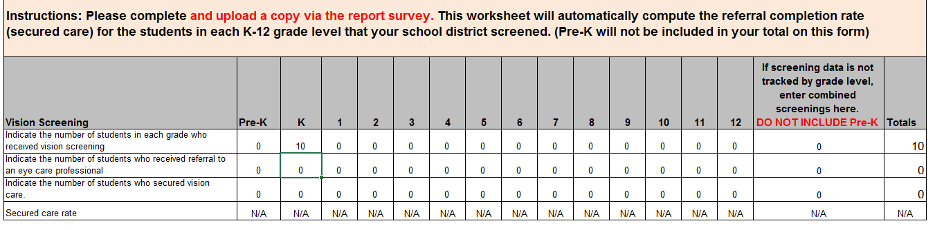
Cells for # screened, # referred, and # secured care have been pre-populated with zeros. If you have numbers to enter that are greater than zero, enter them in the appropriate cell. Do not delete the zeros. For the secured care rate, the formulas have been set to calculate for you based on the number of K-12 students referred and the number of students screened. If there were zero referred and zero screened, the pre-set formula will show "N/A" for secured care instead of 0%. Please Note that #screened will ALWAYS be zero or higher. These cells are not to be left blank. See example below.

Number screened: Include the number of students who were screened in all large group screening projects at school in addition to the students screened individually throughout the school year by grade level. (If the screening program is set up so that the number of students initially screened is not known and the nurse only does a re-screen on those students who are referred to them, then enter the number the nurse referred and/or secured care in the appropriately labeled cells and leave the ‘Number Screened’ cell zero if unknown. Grade-level information is preferred. However, a column has been added for combined numbers in the event the data is not tracked specifically by grade level. If you do not currently maintain the numbers by grade level, you are strongly encouraged to begin doing so.
Number referred: Number of students referred to the appropriate healthcare provider for diagnosis/treatment because of the screening.
Number secured care: Of the number of students who were referred, enter the number who were seen by a health care provider. A health care provider is someone licensed to diagnose the suspected health problem identified at school through the screening project. Further treatment may or may not have been necessary, and a copy of the outcome of that assessment by the provider is not necessary in order to consider the student as having secured care. Parental report of having accessed a health care provider in response to the referral is sufficient, although if possible, further information is desirable for the school nurse. **Formulas have been included that allow for the percentages for secured care to self-populate. If there were zero referred and zero screened, the pre-set formula will show "N/A" instead of 0%. The form has been protected to avoid the accidental deletion of the formulas.
Note: For the purposes of this report, DPH is seeking information only on screenings that may create a barrier to learning and thus impact education. If other screenings are conducted to meet local expectations or grant requirements, they are not required to be reported here. A column for pre-k numbers is provided for local use but that data is not included in the Excel formula used to calculate totals for the “total column” as the Annual School Health Services Report only reports data related to the K-12 student population.

