YMCA
2020 Annual Campaign Email Sample

Instructions:
The email template on page two is in a table format to make it easier for you to send. Please copy the whole table, paste it in your email and center it when you are ready to send. There are highlighted field for you personalize, please change those accordingly.

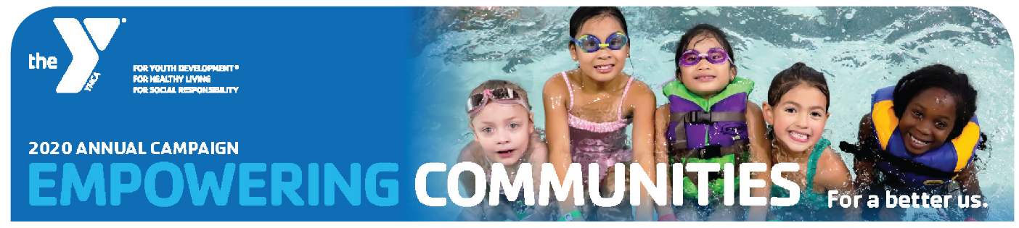
Dear Friends,
The YMCA would like to invite you to help us empower communities to become safer, healthier, and stronger. With your help, the YMCA can make that community a reality by keeping kids safe through drowning prevention, making kids healthier through family outreach programs that address childhood obesity, and strengthening our youth’s future through YMCA Afterschool, Summer Camps, and leadership programs such as Youth and Government and Model United Nations.
All of us have had moments in our lives which shaped our sense of who we are. I am proud to say that the Y is filled with staff and volunteers who work hard to help people discover those transformational moments and who truly believe that every person deserves the opportunity to reach their full potential.
I encourage you to EMPOWER your COMMUNITY by donating to the Y today. If you would like more information about the YMCA, ask me! I am campaigning for the YMCA Lamplighter Afterschool and I would love to share my experience as a YMCA worker.

Sincerely,
YMCA Team

