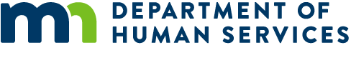

# Need assistance purchasing groceries?

If your child was between the ages of 5 and 18 on September 1, 2019 and was eligible for free or reduced-price meals during the 2019-20 school year, you could receive $325 per child in Pandemic EBT (P-EBT) benefits. These benefits can help your family purchase groceries and are available even if your child continued to receive school meals during the distance learning period. This program is a benefit for your child, and applying for P-EBT does not affect enrollment in any other program.

If you are already enrolled in the Supplemental Nutrition Assistance Program (SNAP) or Minnesota Family Investment Program (MFIP) – and your case was open as of March 18, 2020 – your benefits will be automatic. If you are not enrolled in these programs, but your child was receiving free or reduced-price meals this school year – or your family accesses food through the Food Distribution Program on Indian Reservations (FDPIR) – you will need to apply for these benefits.

**Families receiving SNAP or MFIP when schools closed on March 18, 2020:**

* Benefits will be loaded automatically to your EBT card.
* You **do not** need to apply or to take any additional steps.

**Families receiving free/reduced-price meals or FDPIR, but *not* SNAP/MFIP, during the distance learning period:**

* You will need to complete an application between June 8, 2020, and June 30, 2020.
* Apply at [**www.mn.p-ebt.org**](http://www.mn.p-ebt.org)
* A card will be mailed to you if you are found eligible. You can use it to buy groceries at most local grocery stores.

If you have questions, or need help applying for or using your P-EBT benefits, please contact the P-EBT Hotline at 800-657-3698.

If your family is having trouble purchasing healthy food, please contact your local county or tribal human services agency or the Minnesota Food HelpLine at [hungersolutions.org](http://www.hungersolutions.org) or 651-486-9860.